**Using Zoom for Remote Labs**

All remote labs will be conducted using the video conferencing app Zoom. Below, you’ll find detailed instructions on how to use and run Zoom. If you have any trouble, please contact BU IT at <https://www.bu.edu/tech/about/help-center/> or contact your class’s Graduate Student Teacher.

Follow the following **4 step process to prepare for your remote labs.**

# **Step 1: Make sure that you have a BU** **Zoom Pro account.**

* In order to participate in the Remote Labs and record your lab group, you need to make sure you are using your BU Zoom Pro/Licensed Account.
* If you sign into Zoom and are redirected to sign in via Kerberos BU systems (like your email and other BU services)-- great! You have signed in using your BU account.
* If you sign into Zoom and you are **not** redirected to Kerberos, you are not using a BU Zoom account. Log out of the non-BU Zoom account and log in via Zoom:
  + <https://www.bu.edu/tech/services/cccs/conf/online/zoom/getting-started/signing-in-using-your-bu-login/>
* What happens if I accidentally signed up for a normal Zoom free account with my BU email?
  + This has happened to many other students! Change the email associated with your normal Zoom account (make sure to confirm this with email verification). Once you have done so, go to this link to sign in with your BU Zoom account:
    - <https://www.bu.edu/tech/services/cccs/conf/online/zoom/getting-started/signing-in-using-your-bu-login/>
* **IMPORTANT: Zoom Cloud recording will not work unless every lab group member is logged in via their BU Zoom account.**
* Other Zoom help:
  + <https://www.bu.edu/tech/services/cccs/conf/online/zoom/getting-started/>

# **Step 2: Downloading and installing the Zoom client**

# **On Mac (Computer or Laptop)**

You can download Zoom at this link: <https://zoom.us/download>. Just click the blue Download button and a file called “Zoom.pkg” will automatically appear in your Downloads folder!

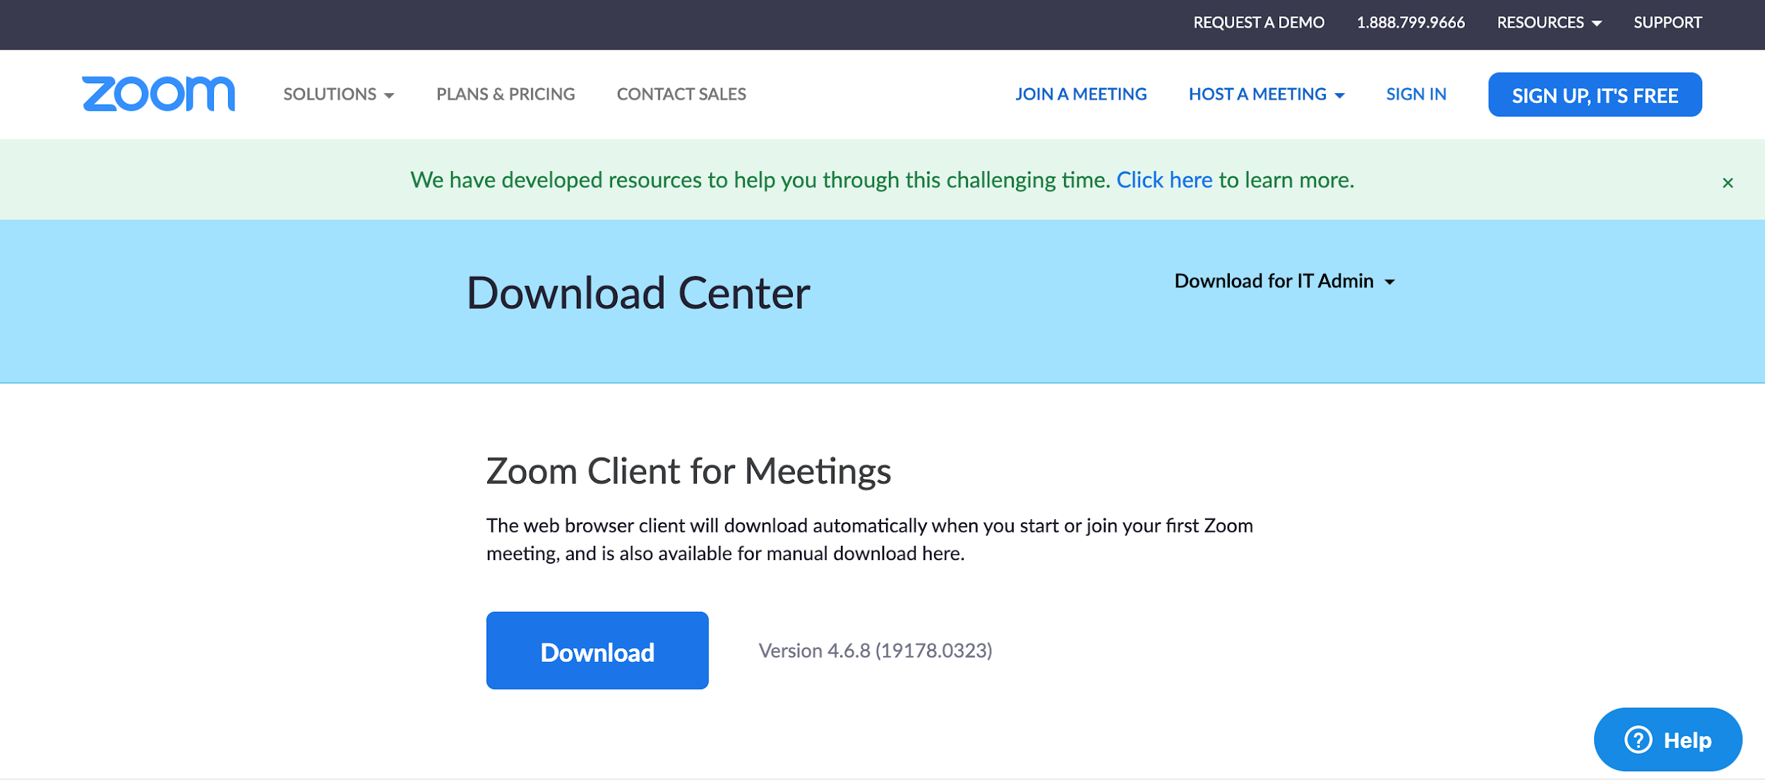

Open “Zoom.pkg” and you will be presented with an Installer window.

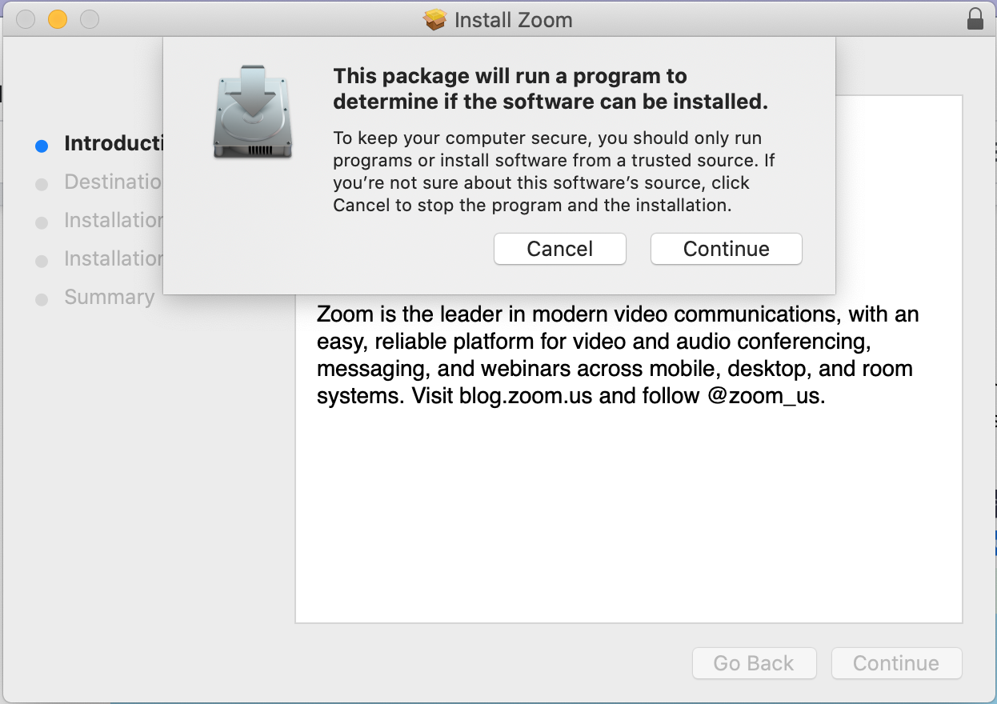

At this point, just follow the on-screen instructions all the way through to the end, and the Zoom app will be installed on your computer.

# **On Windows (Computer or Laptop)**

Go to <https://zoom.us/download> and from the Download Center, *click* on the **Download** button under “Zoom Client For Meetings”. Once the download is complete, *proceed* with **installing** the Zoom application onto your computer. (This is what it looks like on Chrome; for any other browser, follow instructions on screen)

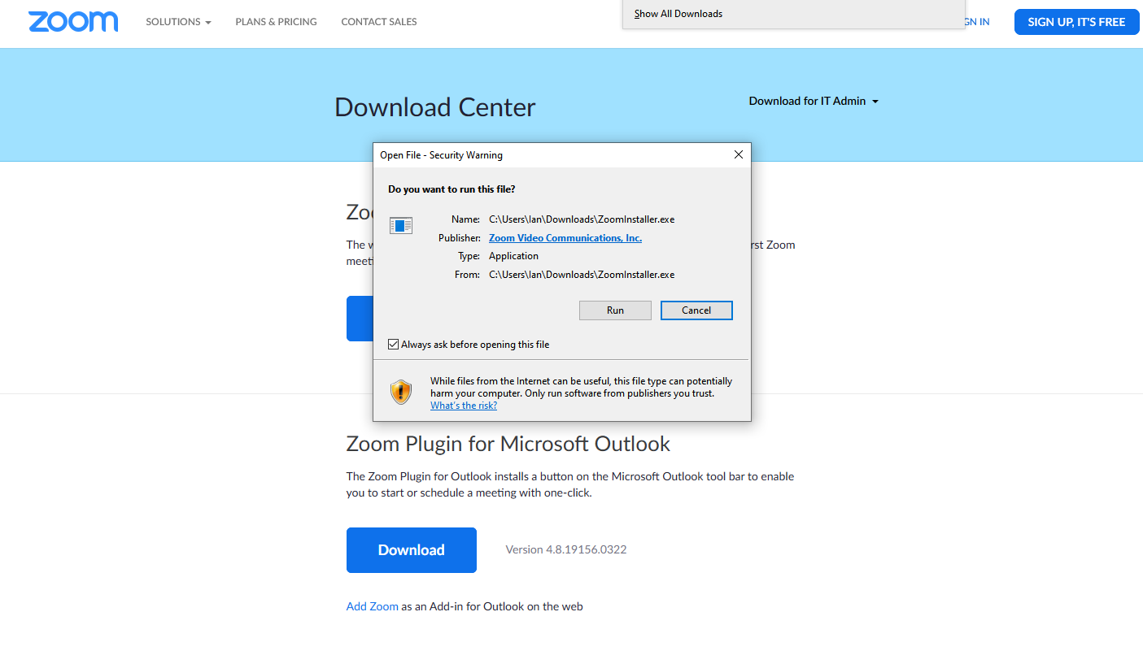

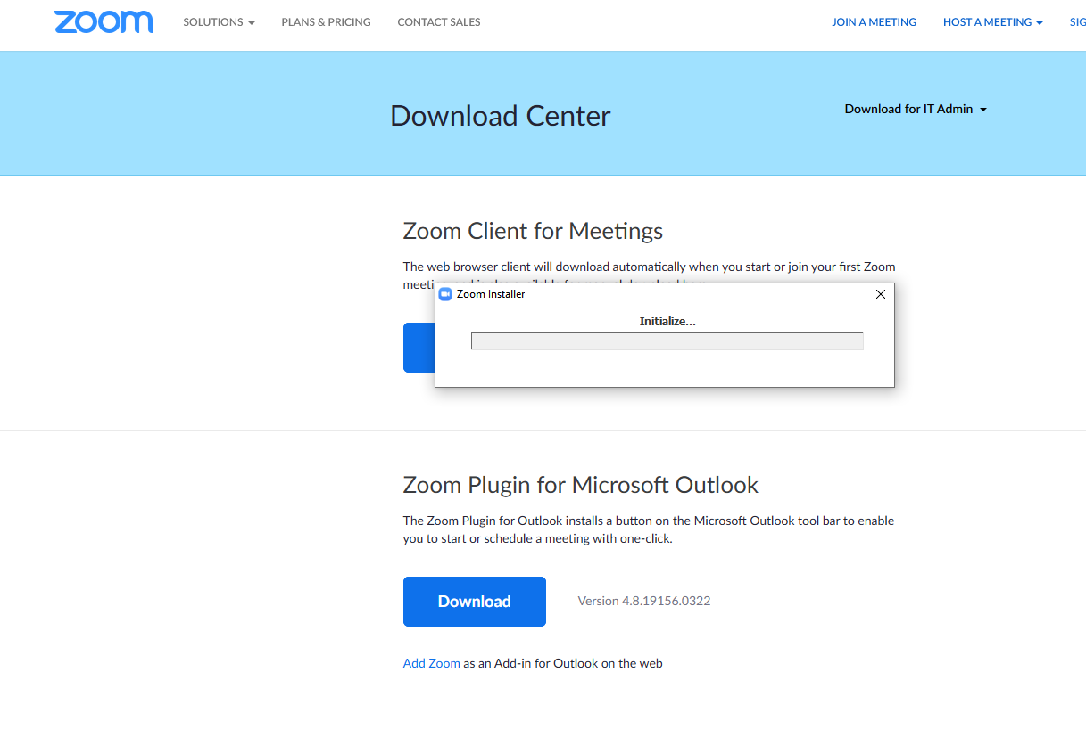

When it is installed and open, you should see a window that looks like this:

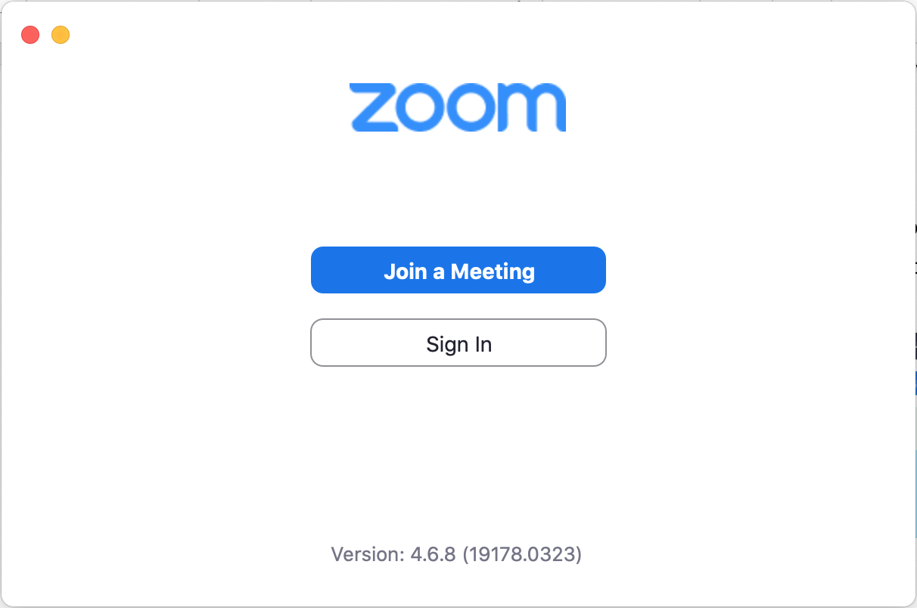

**Zoom Instructions for iOS on Phones/Tablets**

**From the Apple App Store**

There are two apps that look the same. Download the one with more reviews. It should be called “ZOOM Cloud Meetings”.

<https://apps.apple.com/us/app/zoom-cloud-meetings/id546505307>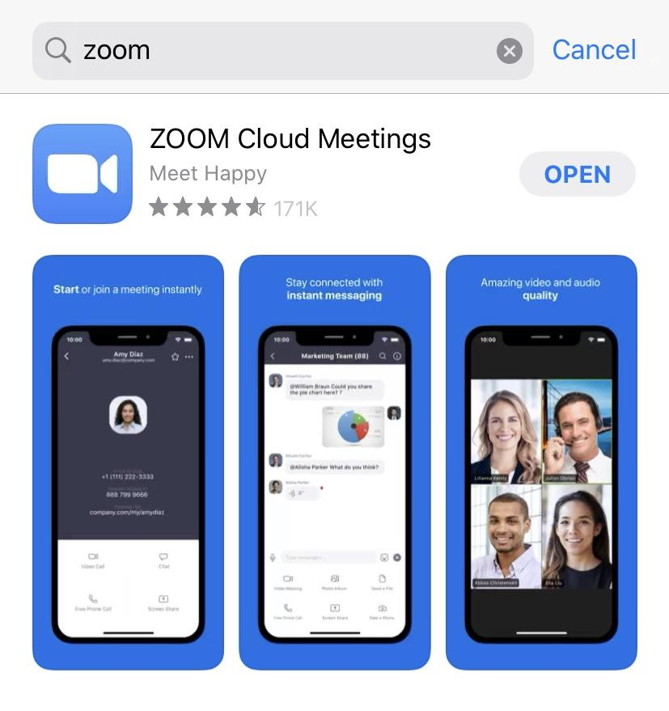

**Zoom Instructions for Android Phones/Tablets**

**From the Zoom app from the Google Play Store**

There are two apps that look the same. Download the one with more reviews. It should be called “ZOOM Cloud Meetings”.

<https://play.google.com/store/apps/details?id=us.zoom.videomeetings>

# **Step 3: Make sure you are signed in with your BU Account:**

* If you are logged in to the right account, when you click on your profile picture/your initials picture, you will see your BU account listed under your name and “LICENSED” or “PRO” in big letters next to your name. It should look something like this:

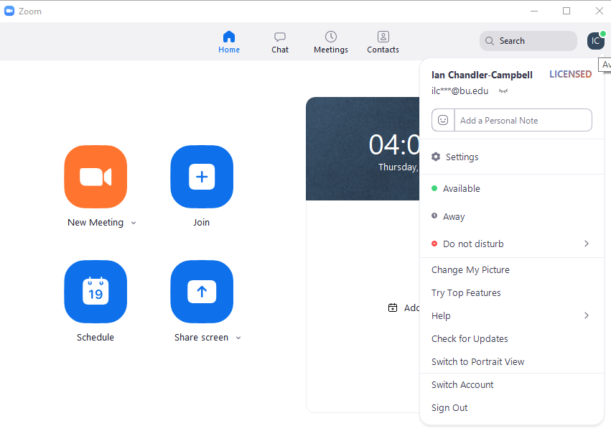

# **Step 4: Make sure you have the right Zoom settings selected.**

* You can open up your Zoom settings in the same way you checked that you were signed in on the right account. Click on your profile picture/initials on the client and navigate to “Settings”.
* The main settings you will see are:
  + General
  + Video
  + Audio
  + Share Screen
  + Chat
  + Virtual Background
  + Recording
  + Profile
  + Statistics
  + Keyboard Shortcuts
  + Accessibility
* For the remote labs, you need to make sure a few different settings are selected. Click on “View More Settings” under the General settings. This will open a web portal with more options for settings.
  + Meeting
    - In Meeting (Basic):
      * Turn “Always show Meeting Control Toolbar” to ON
      * Turn “Show Zoom windows during screen share” to ON
  + Recording: Turn on all settings you see in the following screenshot (see next page):

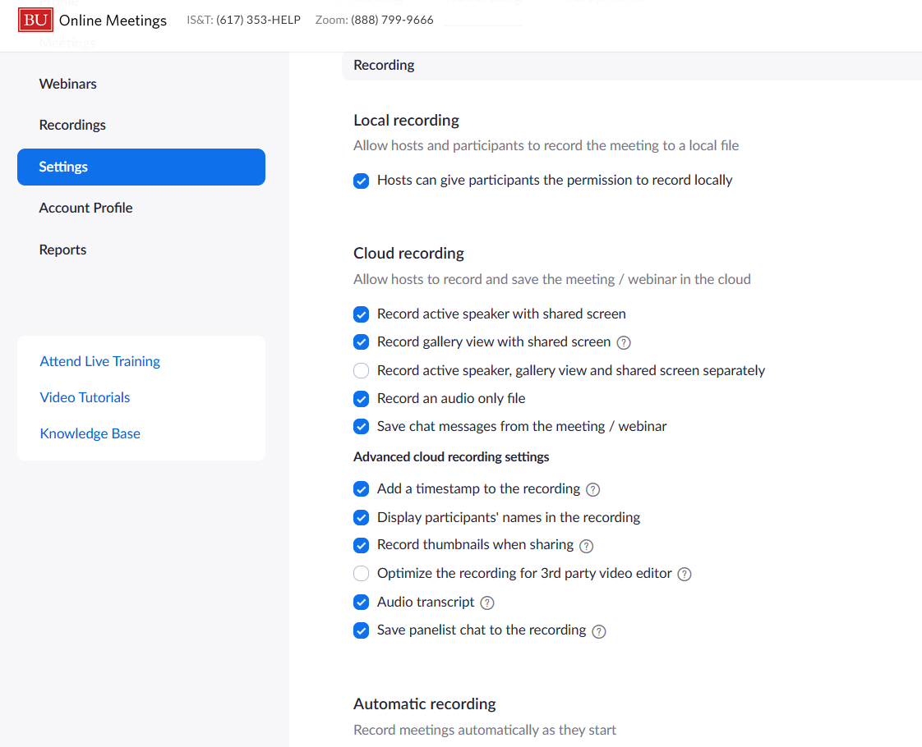

* Additionally, lower in this list, make sure that “Require password to access shared cloud recordings” is ON and “Auto-delete cloud recording after days” is OFF.

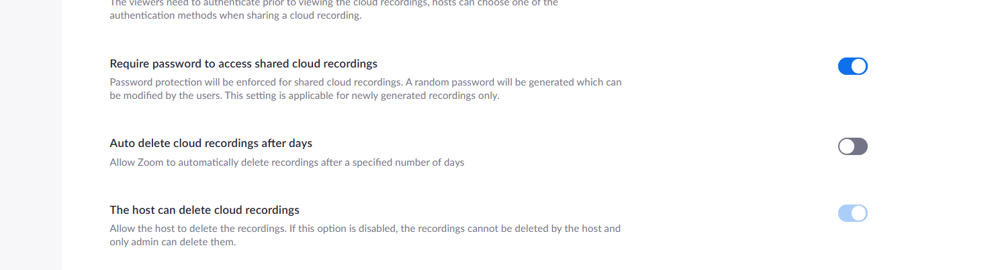

* These are the only settings you need to make sure to have enabled/disabled. Once you finish these settings, you are set and ready to go for your remote labs!